C219 Front-end Web Development

**Lesson 11**

Worksheet

Getting Started with WordPress

This worksheet will guide you through the process of installing WordPress in your local machine, adding content and customising your WordPress website. We will be creating a **News website**.

Before you start, ensure that you have installed [XAMPP](https://www.apachefriends.org/index.html).

1. Launch XAMPP and start **Apache** and **MySQL**.

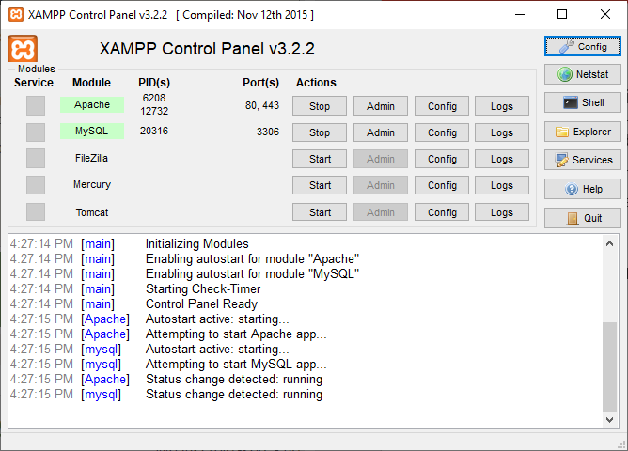

If you see errors in the log, go to Windows Search > type Services > Find all "VMWare" services > Disable. Restart XAMPP.

1. Launch Google Chrome and go to <http://localhost>. You should see the page below. Your local development environment is now ready.

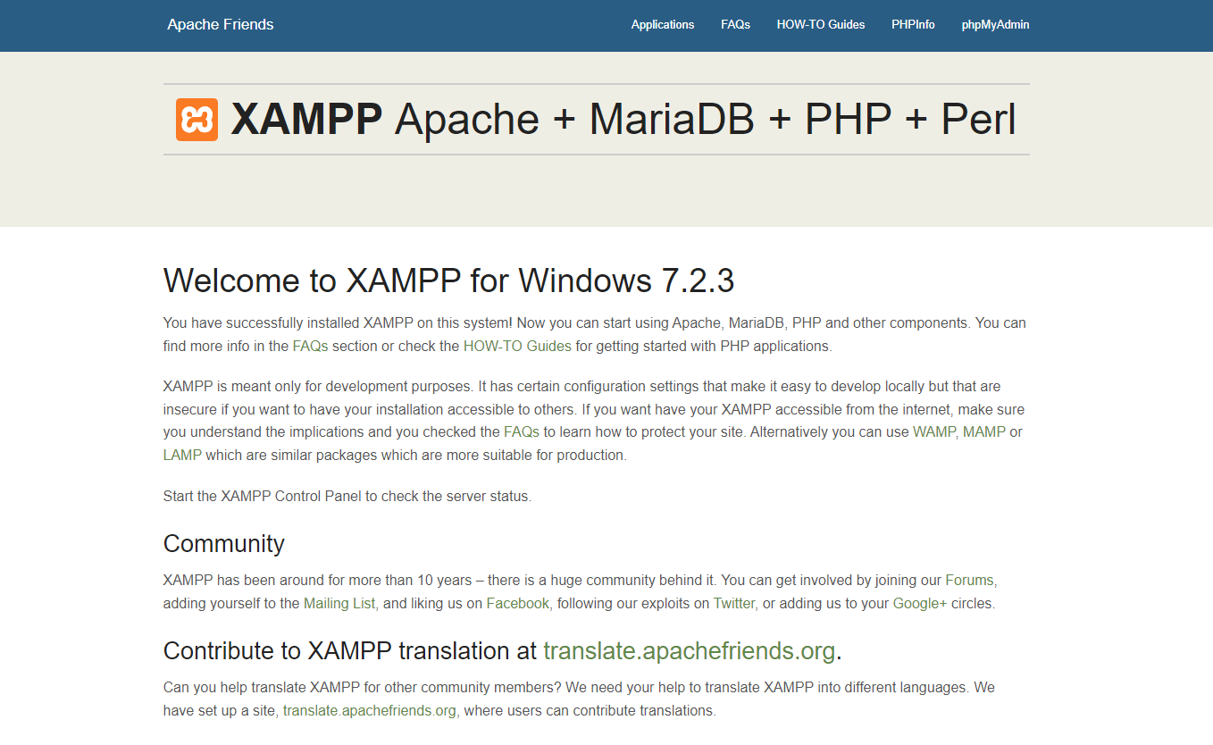

1. Download [WordPress](https://wordpress.org/download/) 6.1.1. Unzip the file, double click on the unzipped folder. You should see a folder **wordpress** inside. Copy the **wordpress** folder into **C:\xampp\htdocs**. Then go to <http://localhost/phpmyadmin> and create a new database named **wp_db1**.

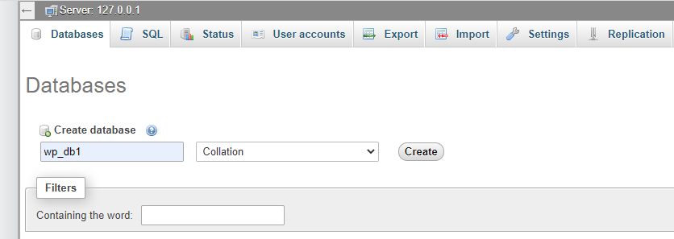

1. Go to <http://localhost/wordpress> to begin the WordPress installation. Select **English (UK)** and click **Continue**.

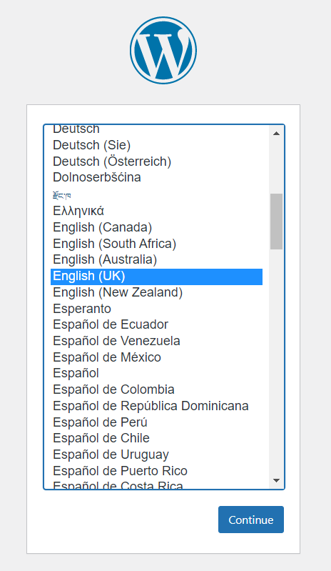

1. You should see this page below. Click **Let’s go!**

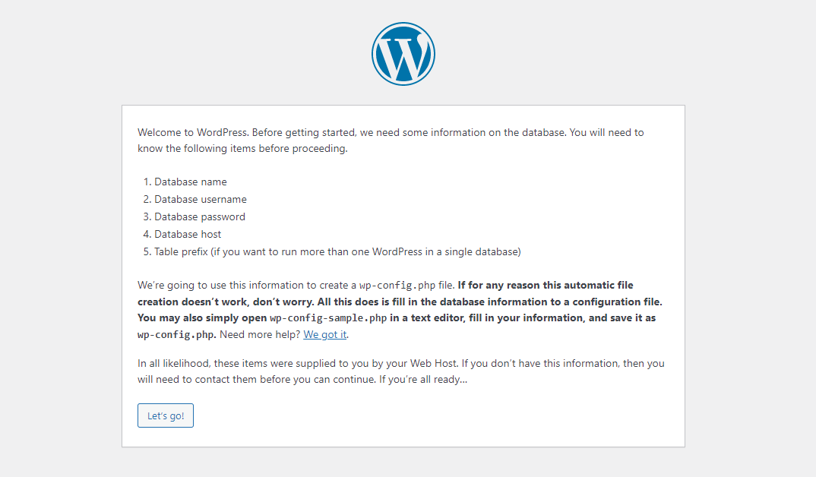

1. Fill up the text fields as follows:

|  |  |
| --- | --- |
| * Database Name: **wp_db1** * Username: **root** * Password: **[empty]** * Database Host: **localhost** * Table Prefix: **wp_**   Click **Submit**, |  |

Click **Run the installation**.

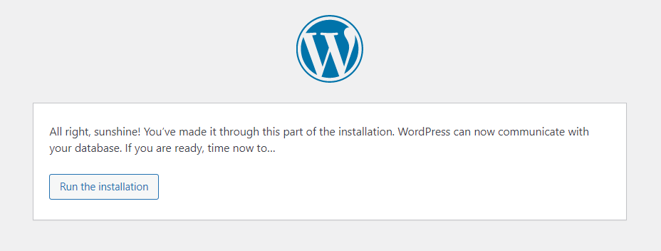

1. Enter all the information below (this can be changed later). Make sure you remember your Username and Password. You will use them to log in to your admin panel. Once you’re done, click **Install** **WordPress**.

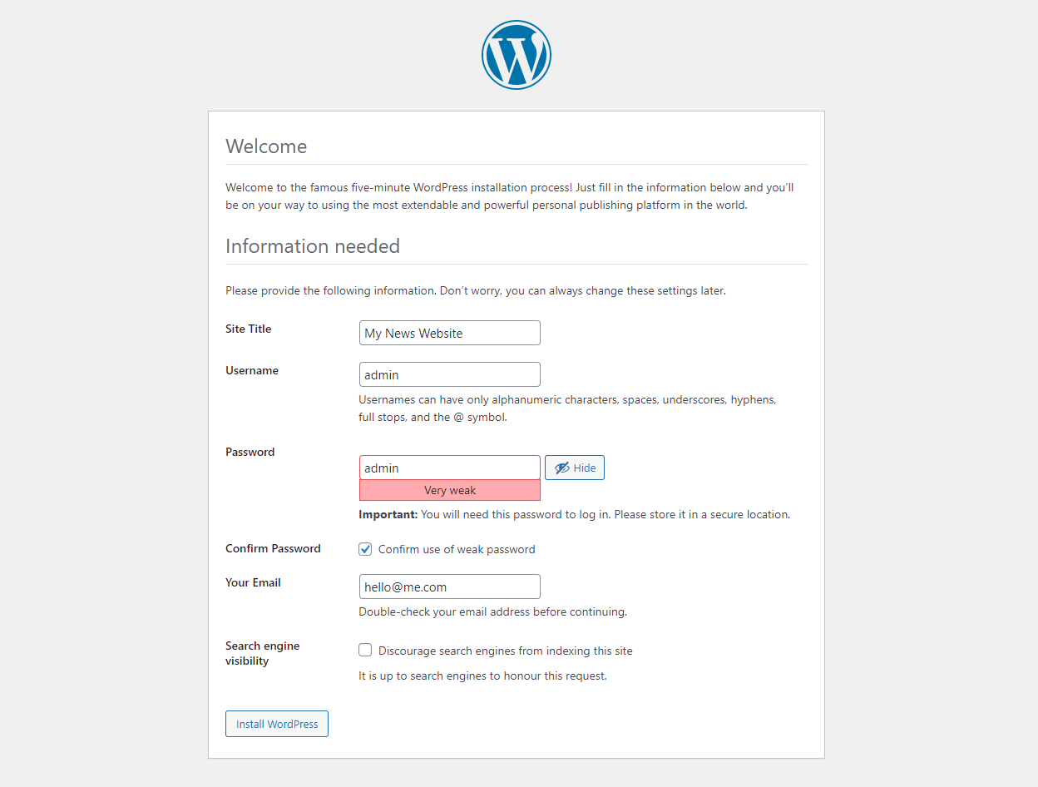

1. Hooray! You have successfully installed WordPress. Click **Log In** and enter your Username and Password to access your admin panel.

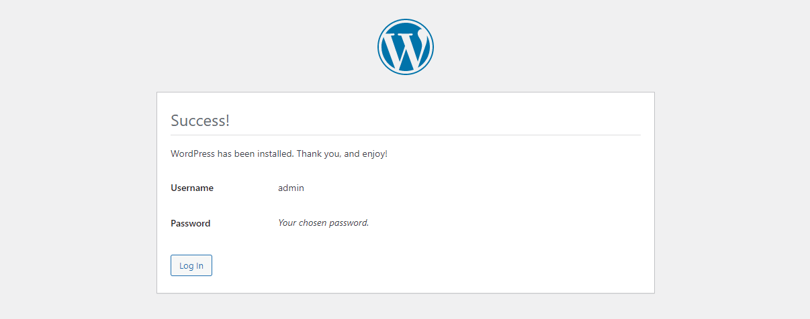

WordPress Admin Panel

1. The Dashboard is the first screen you see when you log into the admin panel. Here, you can customise the screen by clicking **Screen Options** (at the top right corner) and also rearrange the widgets by dragging them.

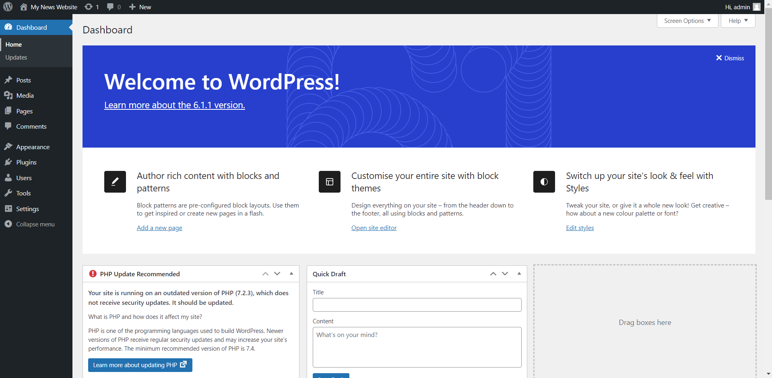

1. Go to **Settings > General**. You can change your website settings here such as Site Title, Tagline, Timezone and Date Format.
2. Go to **Users**. Here, you can manage users, change your password, customise your admin panel colour scheme and more.
3. Spend some time exploring the admin panel. Once you’re ready, proceed to the next section.

Adding Content to your WordPress Site

1. From the admin panel, mouseover the home icon on the top left corner and **Ctrl + click** to open your website in a new tab. Your website is currently using the default theme and there isn’t much content, so let’s add some.

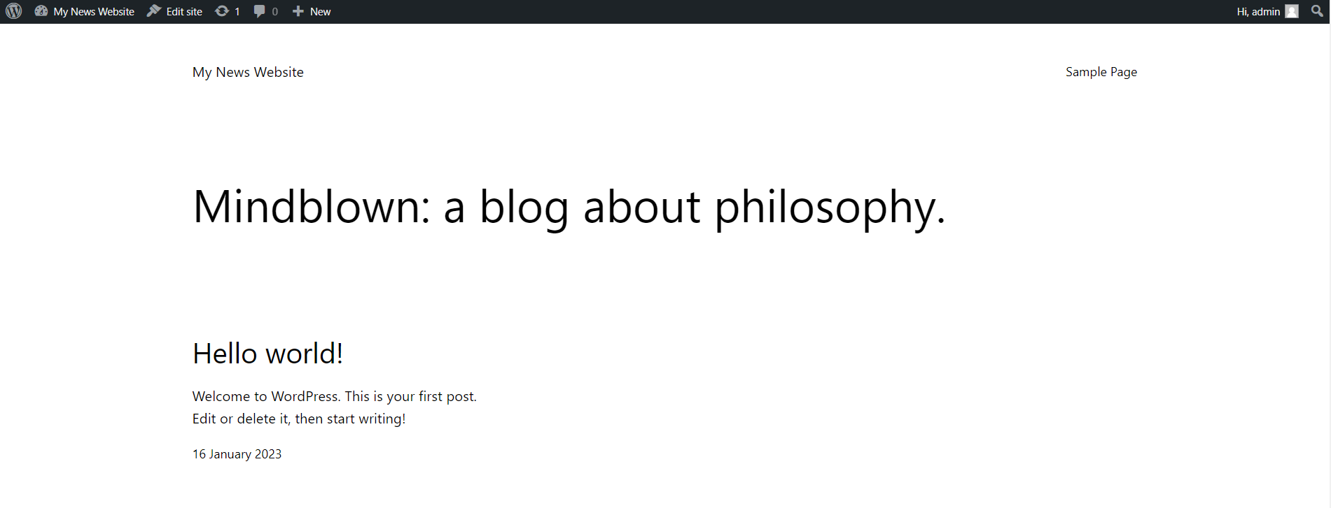

1. **Adding Pages**  
   On the admin panel, go to **Pages > Add New**.

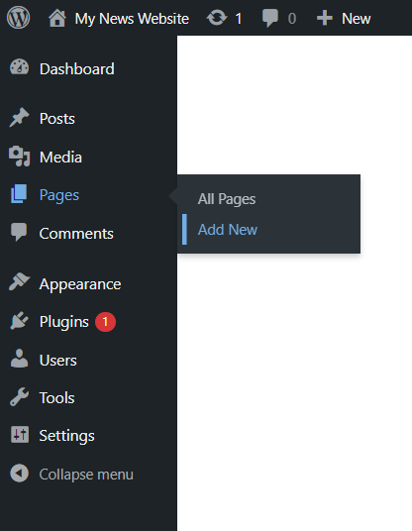

You will be directed to the Page Editor. Give your new page a title such as **About** and add some text to the page. You can add blocks and patterns by clicking on the **+** icon at the top left. Spend some time exploring the editor. Once you’re done adding content to your page, click **Publish**. Then go back to the admin panel by clicking the **WordPress logo**.

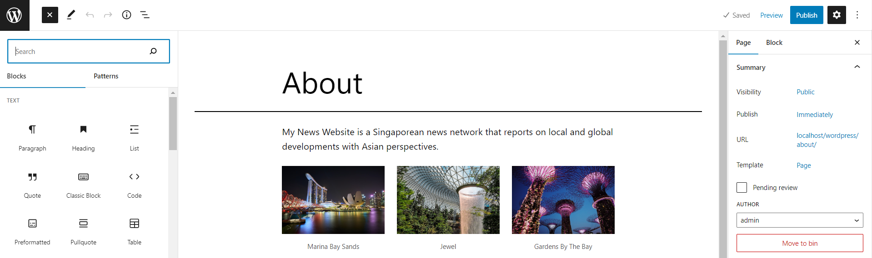

**Refresh** your website (<http://localhost/wordpress>). Your navigation menu should now appear at the top of your page, containing your newly added page - About. Click on it and you should see the page that you just created.

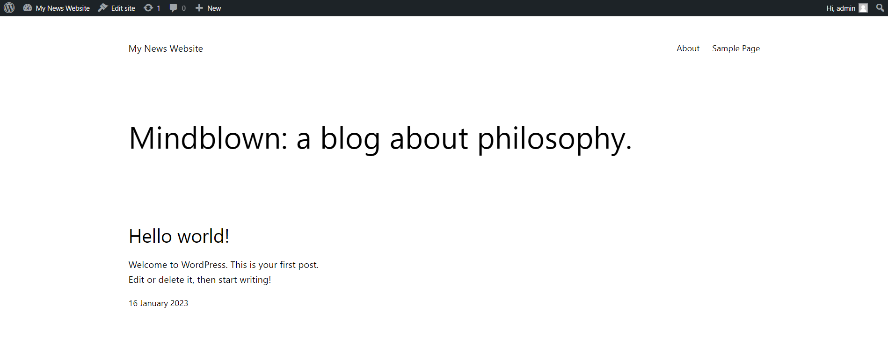

1. **Adding a Page containing the Latest Posts**  
   In WordPress, pages are used for static content (e.g. About or Contact pages), whereas posts are for more timely content that is regularly updated (e.g. news or blog posts). Let’s create a page containing a list of the latest posts.  
     
   Create a new page called **Latest News** and add the **Posts List** block to the page. Select “choose” to find your idea template for each post. You can change its settings and appearance by selecting the block in the editor panel.

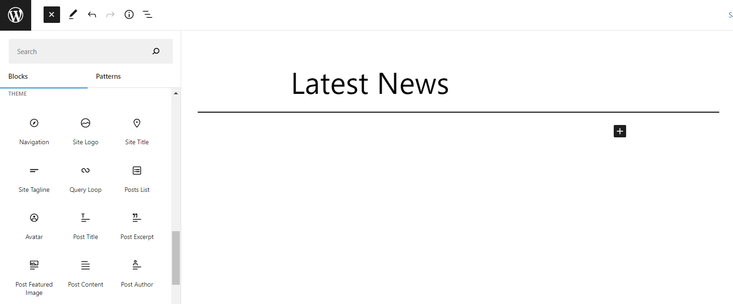

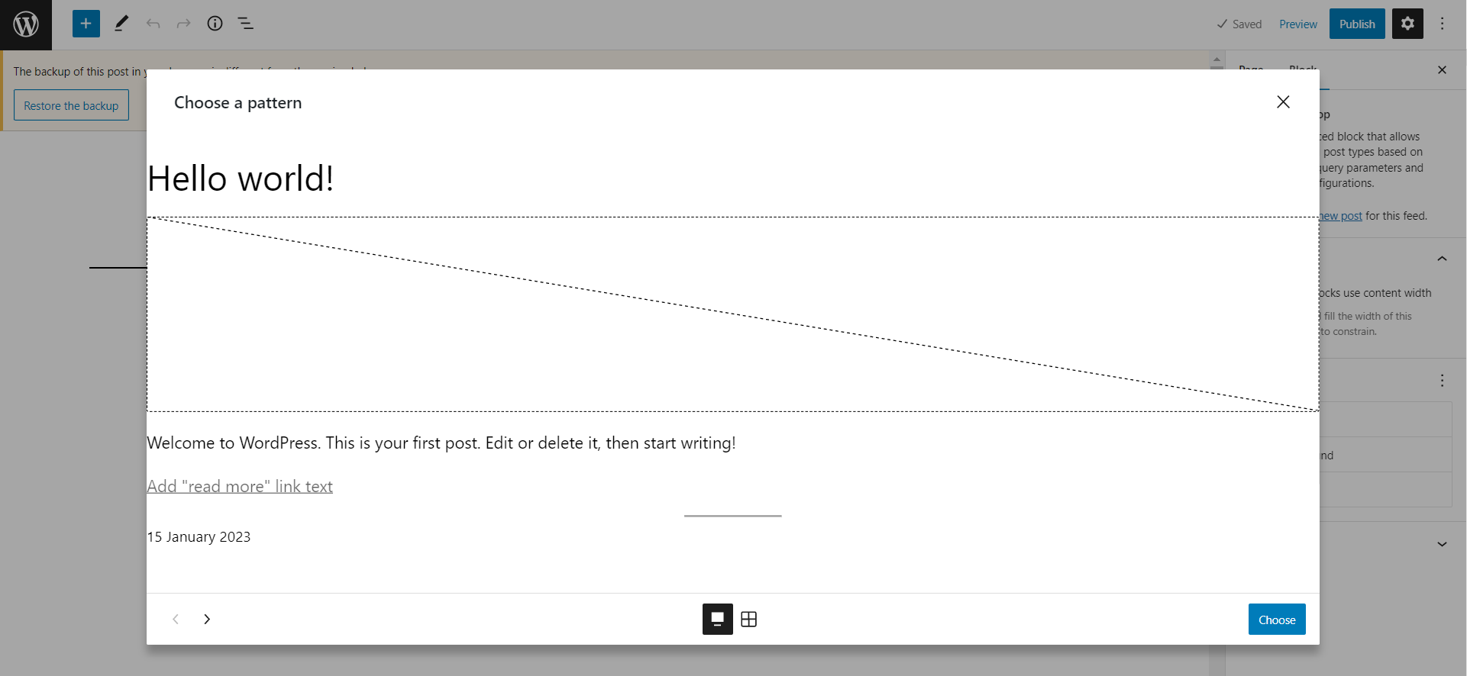  
**Publish** your page and refresh your website to view the changes. You should see **Latest News** added to the main menu at the top. When you click on it, you should see the **Hello world!** post, which is the first default post in WordPress.

1. **Managing Posts**  
   From the admin panel, click on **Posts**.

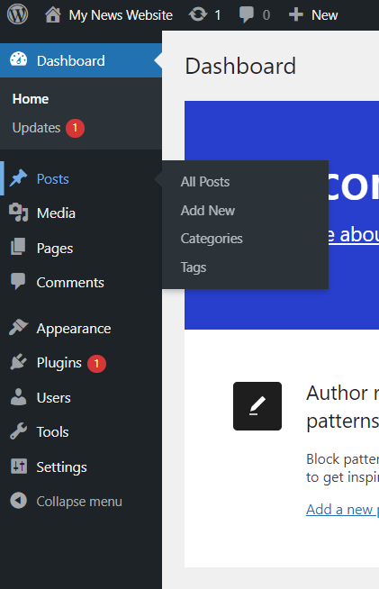

You should see the Hello World! post listed. Click on the **post title** to edit it.   
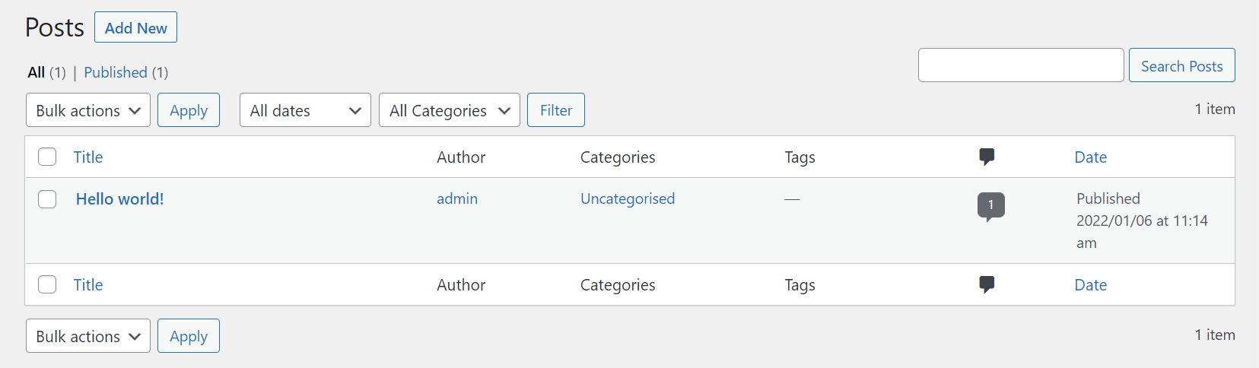

In the post editor page, click the **Settings icon** at the top right.

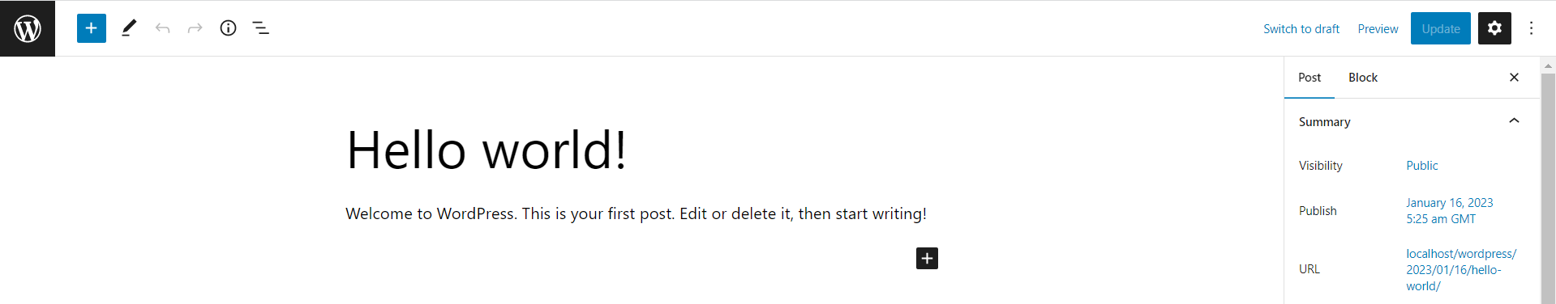

Here, you can manage post settings like categories, tags, featured image and comments. Add a **new category** for this post and set a **featured image** for it. Once you’re done, click **Update**.

You should now see a thumbnail beside your post in the Latest News page. When you click on the post, you should see the featured image at the top of the page.

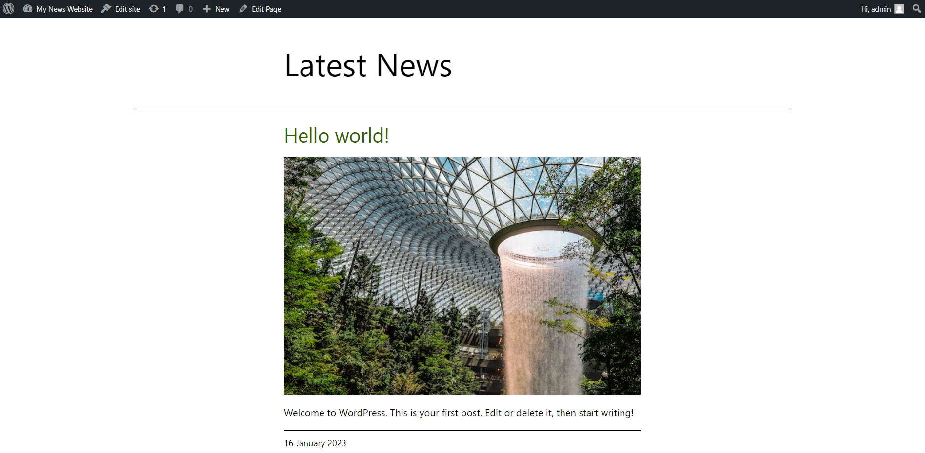  
  
If you click on the post, you will also notice a comments section at the bottom. WordPress allows commenting in posts by default, but you can change the comment settings within the post settings or in the admin panel **Settings > Discussion**.

Now **add more posts** to populate your Latest News page.

Customising your WordPress Site

1. **Customising your Theme**

Go to **Appearance > Editor > Settings**. You can customise your site identity, colours, home page settings and more. Add a **logo** and **icon** for your site, change the **background colour**, and customise **widgets**. Once you’re done, click **Publish** to view the changes.

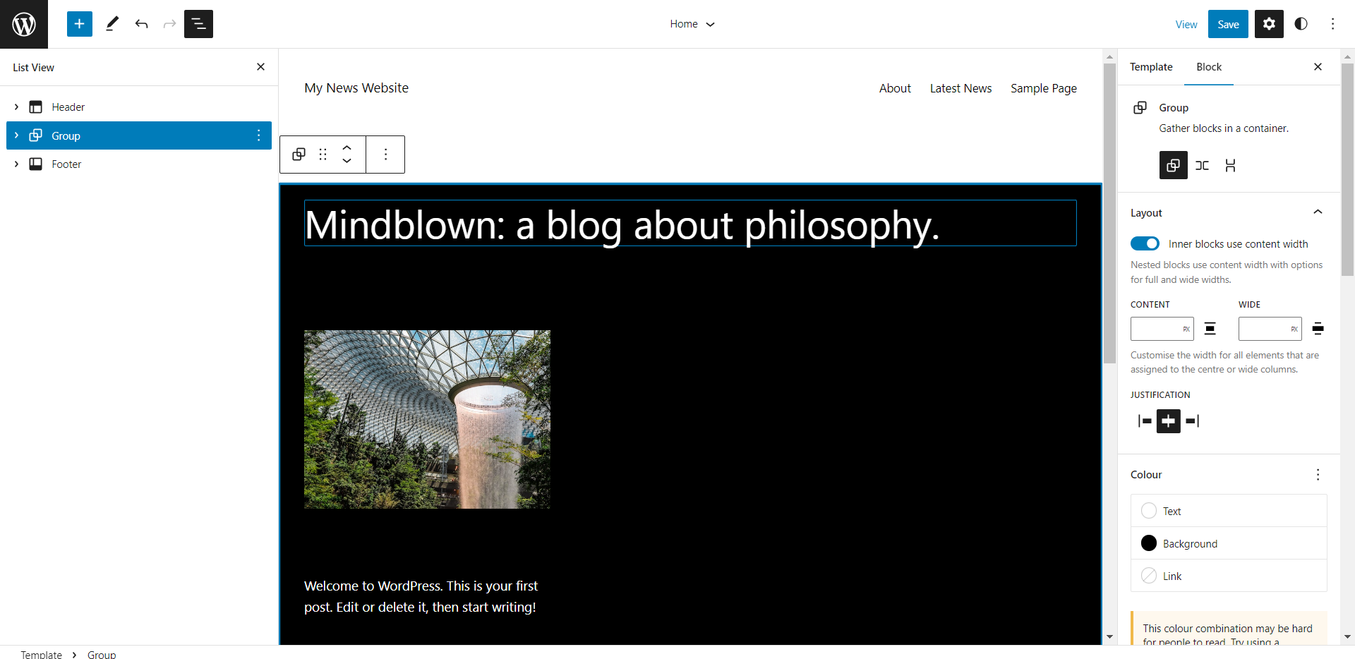

1. **Changing your Theme**

Now, let’s change the website theme. Go to **Appearance > Themes** and click **Add New**. WordPress offers thousands of free themes. Browse for your favourite theme (use the Feature Filter to narrow down your search) and click **Install** and **Activate**. Try out different themes until you find a suitable one for your news website.

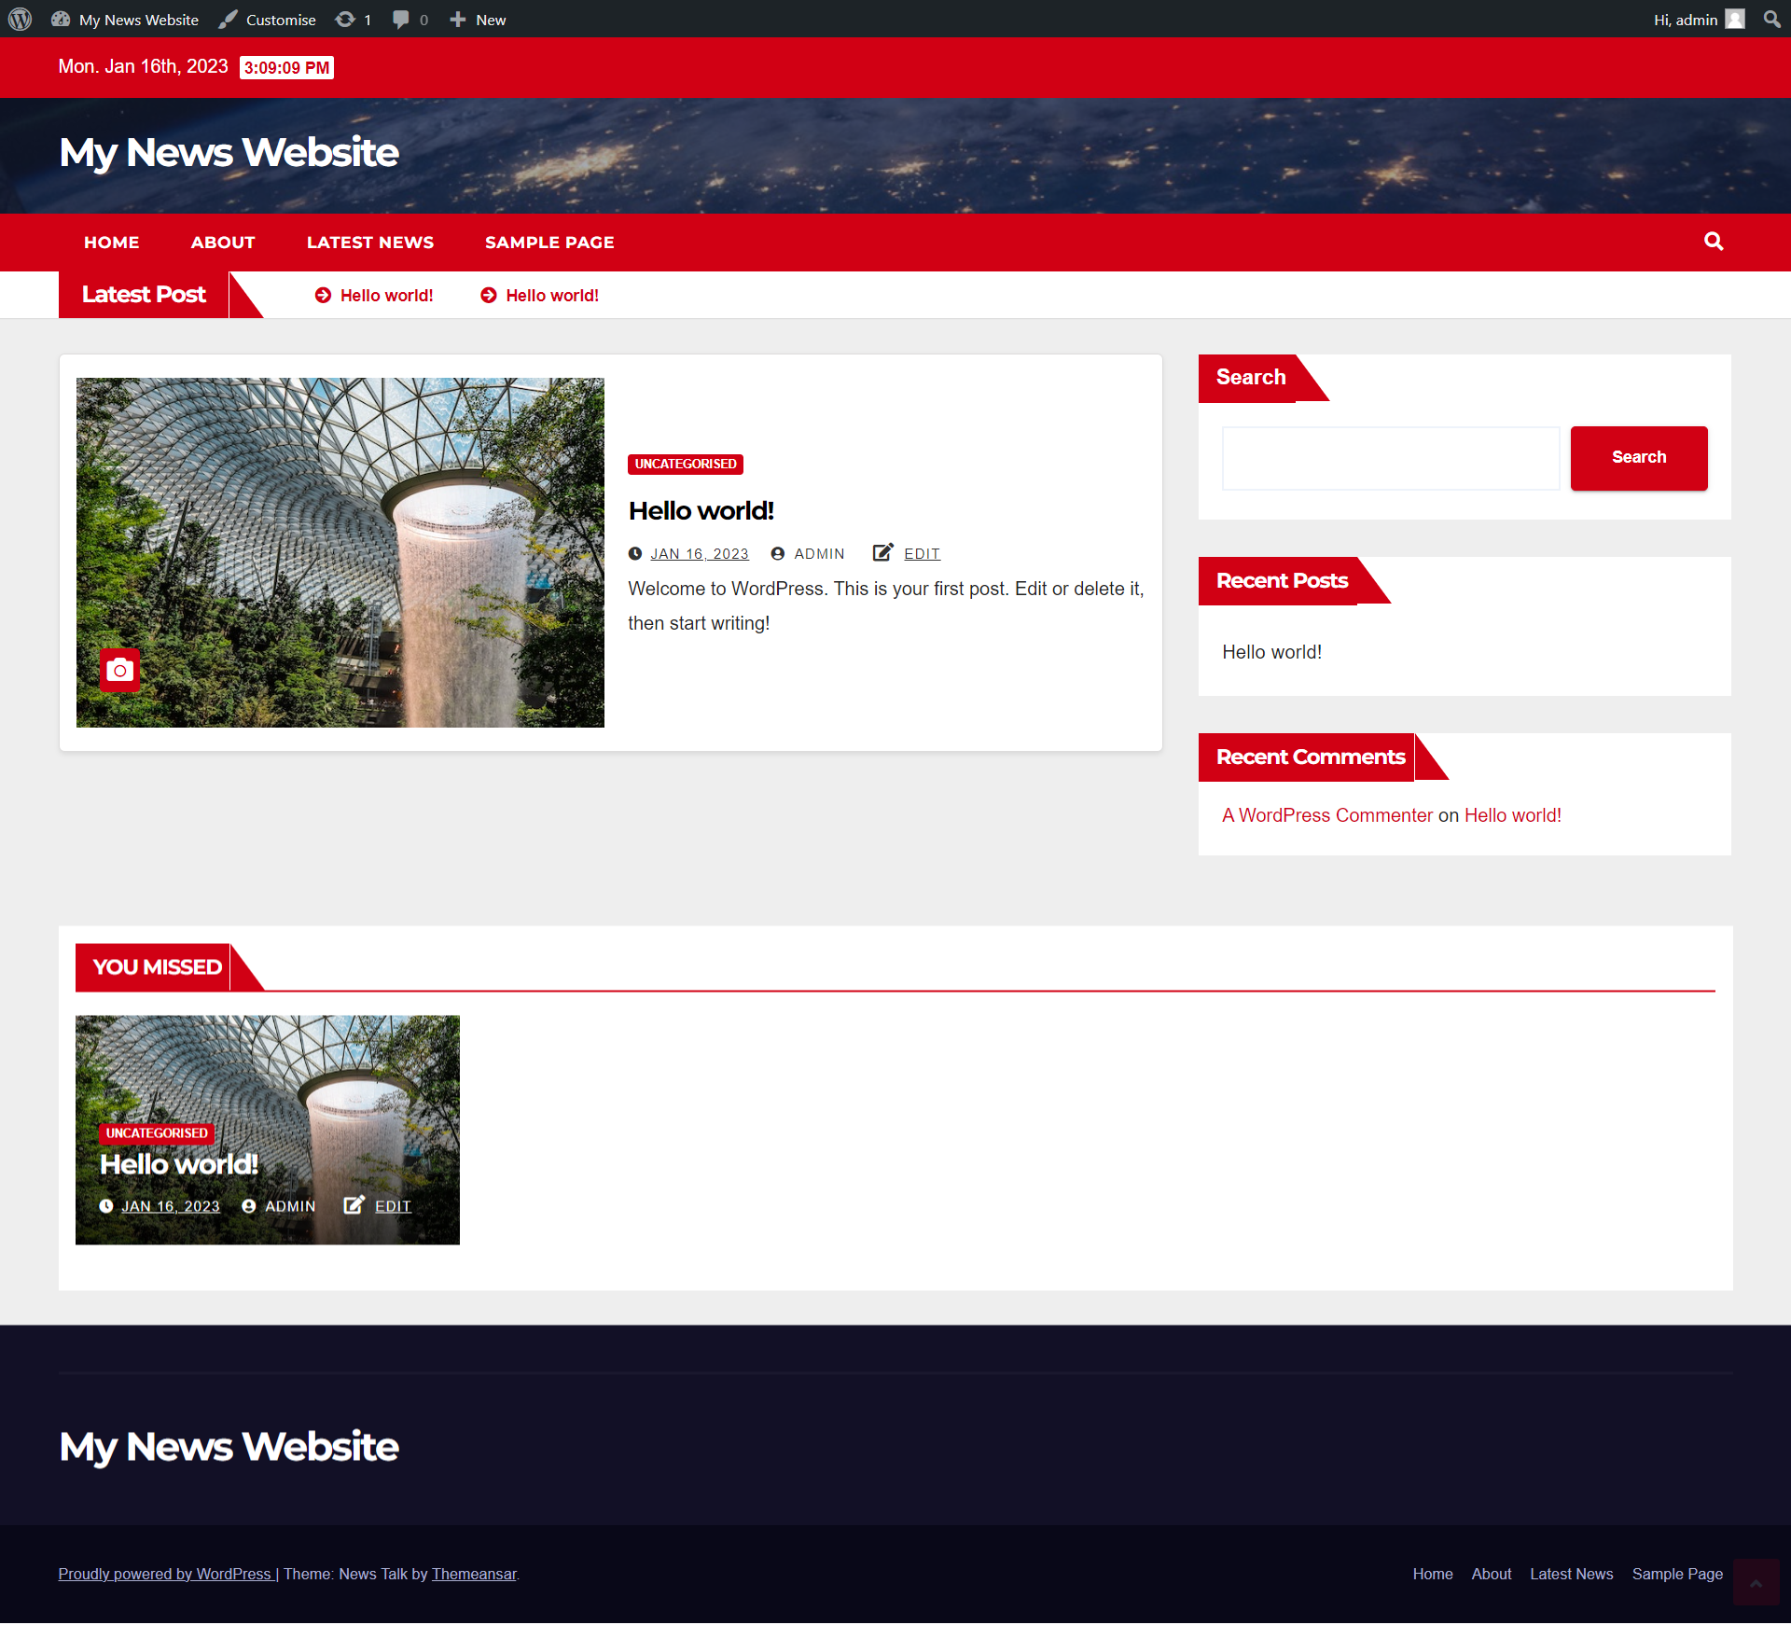

News Website Example

1. **Applying Custom CSS to your Theme**

There will be cases when you want to apply certain styles to your website’s elements which are not available from the admin panel. You can add custom CSS in two ways:

1. Appearance > Customise > Additional CSS
2. Manually editing the theme’s **style.css** file

The second method is recommended as it allows you to write code in a more efficient manner using an IDE. **Locate your theme’s style.css file** which is inside your theme folder, and open it in Visual Studio Code.

In this example, the red search button will be changed to black using custom CSS.

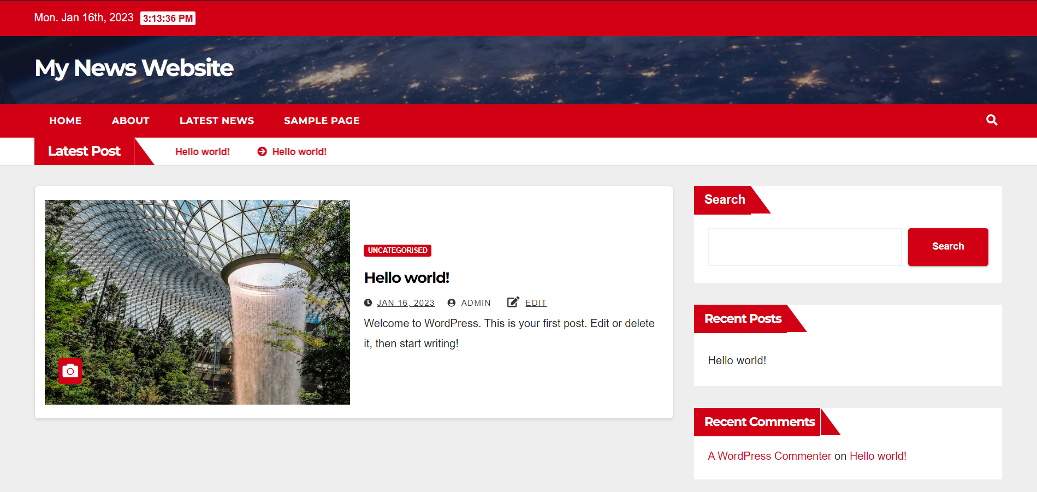

Use **Chrome DevTools** to find out the element’s CSS class you want to target.

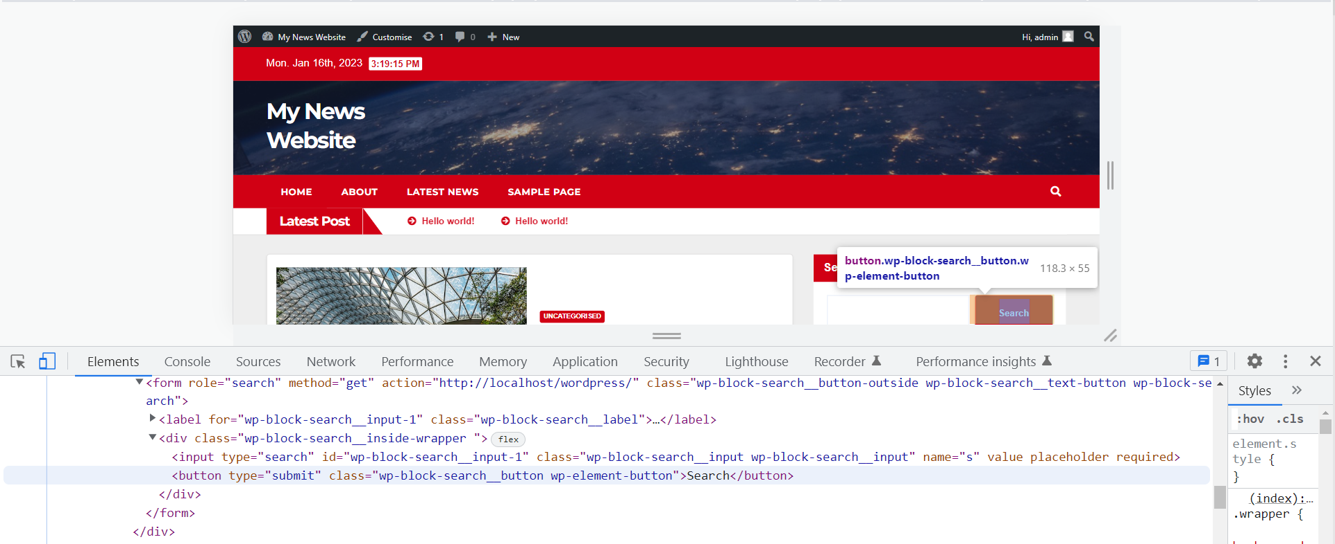

Edit CSS for **the theme’s default.css** file to achieve the result.

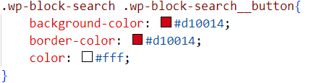

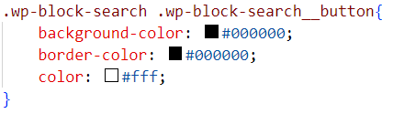

**Result:**

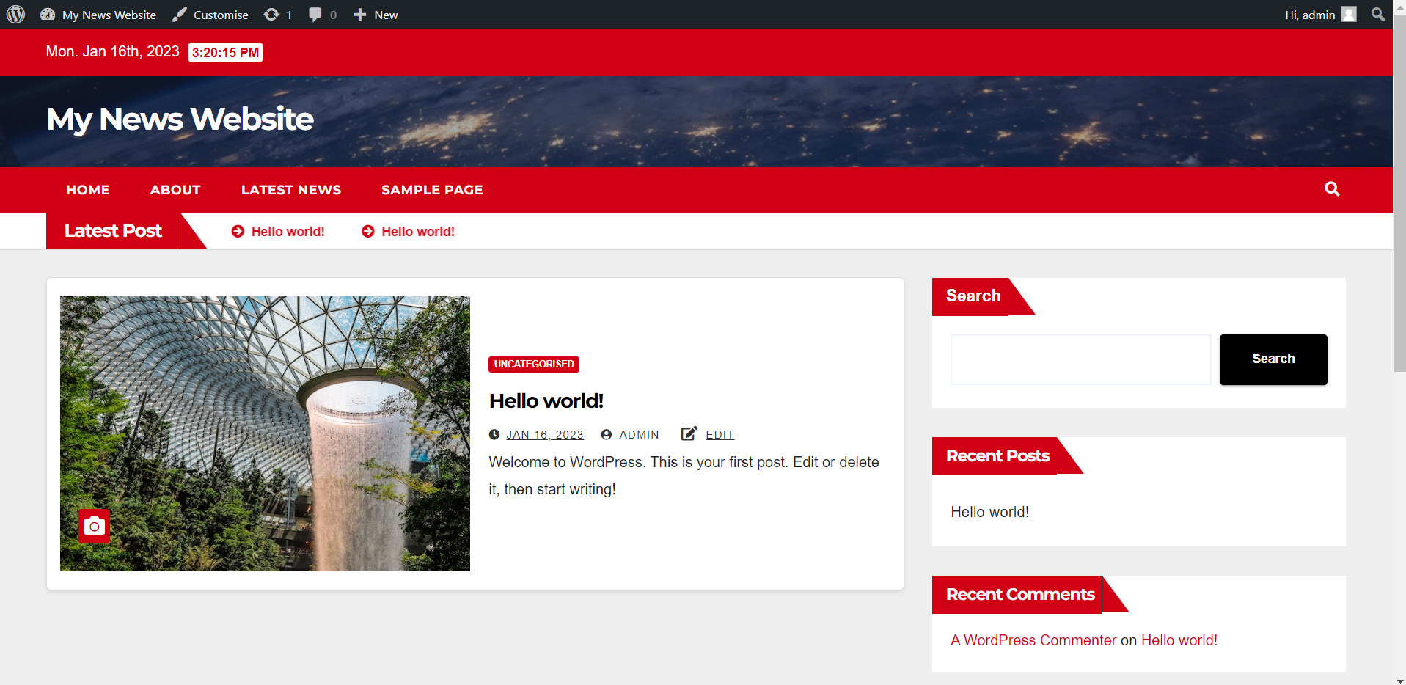

WordPress File Structure

The core WordPress software, themes, plugins, and user uploads are all stored on your **wordpress** folder. You should not edit any files within the red box unless it is necessary. These are the files that run your WordPress site. The **wp-admin** folder contains the files that make up your admin panel.

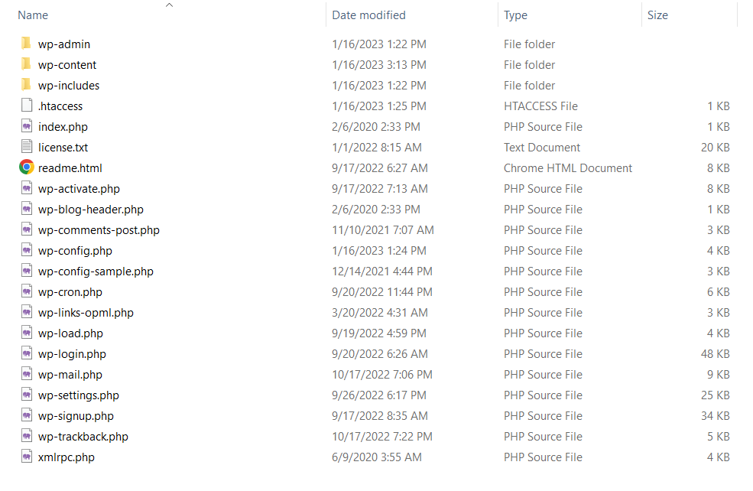

The **wp-content** folder contains your themes, plugins and uploads. The files that are usually edited in this folder are the style.css, functions.php and plugin files.

You will learn how to create a plugin in the next lesson.

Tips and Tricks

**What is the URL for the admin panel?**

<http://localhost/wordpress/wp-admin>

**How to hide the admin toolbar when viewing site?**

You will notice that your website has a toolbar at the top. To hide it, go to Users > admin > Uncheck Show toolbar when viewing site.

**How to remove the edit link from your website?**

Your website might have edit links below your posts. To remove them, comment out the edit_post_link() function in your theme. It should be located in the functions.php file in your theme. If you can’t find it, add your wordpress folder into VS Code (File > Add Folder to Workspace… > C:\xampp\htdocs\wordpress) and Ctrl+Shift+F to search for edit_post_link.

**How to remove the theme link from the footer?**

There are a few ways to do this:

* Go to Appearance > Customise. Find your footer settings and edit the text accordingly.
* In cases where the theme’s link is inserted dynamically, you can use Chrome DevTools to find the CSS selector and hide the element. Then add a new footer widget with your desired footer content to replace the previous hidden footer.
* Purchase the premium version of theme

 **L11 Assignment**

Create a **news website** using WordPress. You can choose any theme for your news site, such as technology, fashion, music, food, sports, games, etc.

Website requirements:

1. Home page
   1. Graphic logo
   2. Navigation
   3. Latest News section with at least three articles
2. About page
   1. Description about the news website
3. News category page
   1. A list of news from a specific category. For instance, if you’re creating a sports news website, you can have a page called Badminton which only displays news articles under the Badminton category.
4. News article page
5. A new theme must be applied (no default themes allowed)

 **Deliverables**

Individual submission:

* **wp-content** folder only (do not submit the entire wordpress folder)
* **wp_db1.sql** file1
* A full-page screenshot of your home page2 (**home-page.png**)
* Place all of the above in a folder and zip for submission

Others:

* RJ

**Submit all deliverables by 2359 today**

1 To export your WordPress database, go to phpMyAdmin > Select wp_db1.sqldatabase > Export > Go. Do not change your database username and password.

2 For full-page screenshot, Install this Google Chrome extension - <https://chrome.google.com/webstore/detail/awesome-screenshot-and-sc/nlipoenfbbikpbjkfpfillcgkoblgpmj?hl=en-US>